Specification of design conditions for cases 1.1 and 6.1c, BS EN 61400-3:2009

1. 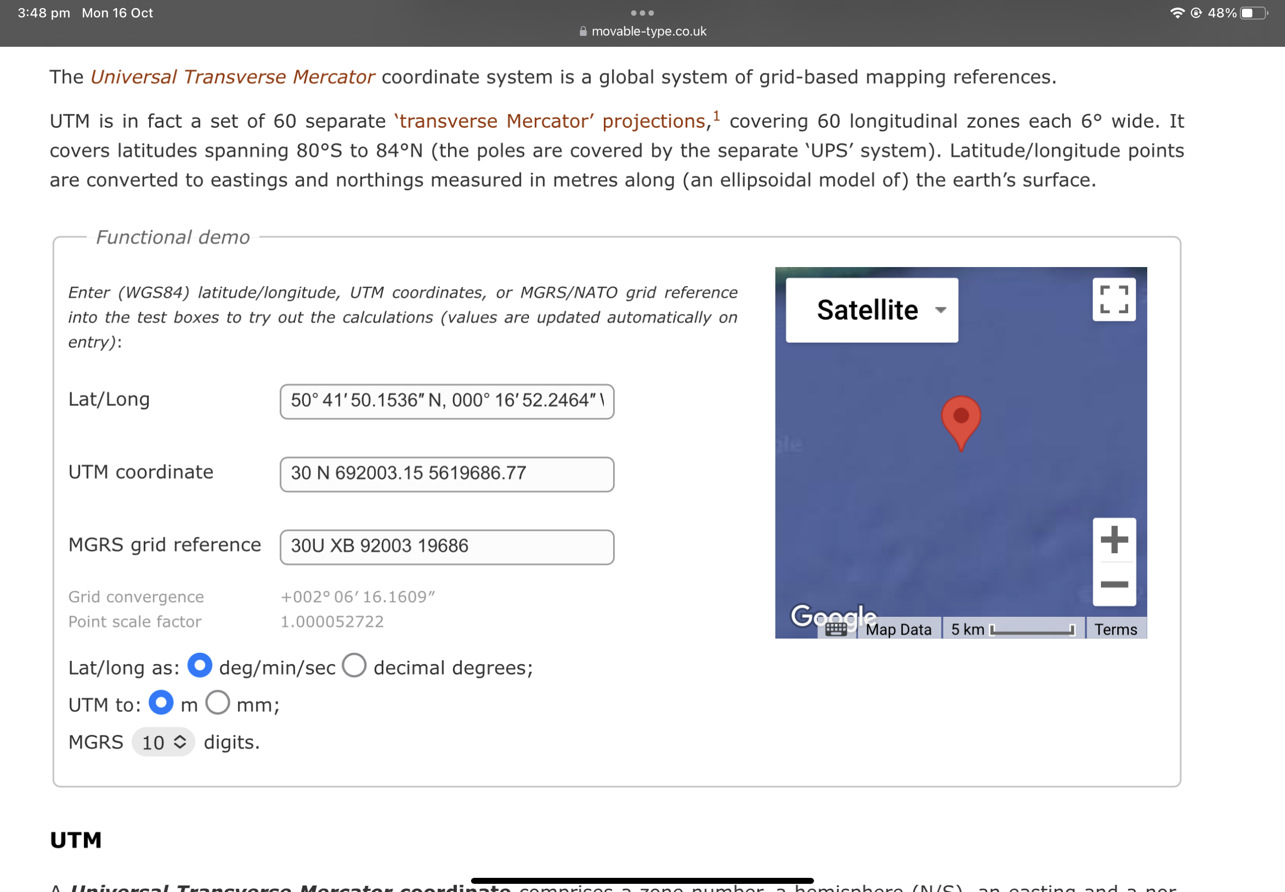(a)  Use the Digimap online map and data service to obtain bathymetric data for your site.



50° 41′ 50.1536″ N, 000° 16′ 52.2464″ W

50.7N, 0.28W

1. (b)  Search the sources of Metocean data to acquire suitable sets of wind, wave, current and tide data.

<https://wavenet.cefas.co.uk/Map>

<https://wavenet.cefas.co.uk/print/charts?id=213&datasource=EXT&start=2023-10-16T07:12:12&showforecast=true&showWQ=false&multi=false>

Data from Rustington according to <https://coastalmonitoring.org/realtimedata/?chart=78&tab=Wave%20Spectra&disp_option=> :

Data from <https://portal.medin.org.uk/portal/start.php#details?tpc=014_1e3ec2e3-7670-4358-accd-90c0862292b2> : Sussex Bay - Rampion Offshore Wind Farm - Spoil Ground - 2m - Bathymetric Survey

1. (c)  Use the data to calculate wind, wave, current and water level parameters for your
2. design cases. Select one particular combination of waves, currents and water levels prescribed by the code for each design case.
3. (d)  Use the following additional considerations and assumptions1:
   1. Assume that current data are taken at the turbine site at the level 10m from the sea surface. For load case 6.1c use the maximal current speed in your data set.
   2. Assume that the tide data is taken at the turbine site. Neglect the random water level component and use water levels of astronomical tides only. For load case 6.1c use Highest Astronomical Tide (HAT) and for load case 1.1 use Mean Low Water Neaps levels.
   3. Assume that the wind data is taken at the turbine site at the height 20 m above the chart datum.
   4. Use wave prediction charts (BS 6349-1-2:2016, Annexe C.4) to calculate wave conditions for load case 1.1.
   5. Use extreme values analysis (BS 6349-1-2:2016+A1:2017, Section 15 and Annex D) to calculate wave conditions for load case 6.1c.
   6. 3rd-year students: Assume that the wave data is taken at the turbine site.
   7. MSc and 4th-year students: Assume that the wave data is taken in deep water.
   8. MSc and 4th-year students: Re-calculate wave height taking into account the difference in depths between the measurement site and the turbine site by applying shoaling consideration.
   9. MSc and 4th-year students: Define if your wave conditions correspond to breaking or non- breaking waves.



Produce a Design Conditions Report describing the data, methods of calculation of design conditions and summarising these conditions for your design cases. The report should include plots of wind and current profiles and wave velocity profiles in combinations required for calculating loads. The report word limit is 2500 words excluding bibliography.

1. Calculate wind, wave and current loads on the wind-turbine installation for the specified load cases. Loads must include: (i) Horizontal force and (ii) Mud-line overturning moment. Use the following additional considerations and assumptions:
   1. (a)  For wind load use rotor trust and tower load for case 1.1 and tower load for case 6.1c.
   2. (b)  Assume unidirectional waves co-directional with currents for both design cases.
   3. (c)  For case 1.1, calculate loads for one selected combination of waves, currents and water levels prescribed by the code.
   4. (d)  For case 6.1c calculate loads corresponding to HAT conditions.
   5. (e)  MSc and 4th-year students: For cases with breaking waves include breaking impact loads to your load calculations.
   6. (f)  Compare loads for both cases and specify ultimate design loads.
   7. (g)  For calculating waves and current loads use the method for slender structures. Discuss the applicability of this approximation for your structure and wave-current conditions. Discuss alternative methods of calculating wave-current loads. You can use Figure 7-1 from DNV- RP-C205 to help you in your discussion.
2. For the surficial seabed sediments at your site calculate if the seabed is mobile and find the critical velocity for bed sediment movement. Specify if scour occurs around the installed substructure and calculate the depth of the scour hole. If required, suggest measures for scour protection. Sediment parameters for your site are specified in EON (2012), including particle size distribution (EON 2012, Appendix H, Table 1), summary statistics (EON 2012, Appendix H, Table 2) and particles description (EON 2012, Appendix H, Table 3). Use the following additional considerations and assumptions:
3. (a)  Assume that the surficial sediment thickness is greater than the depth of scour formed around the foundation.
4. (b)  For sediment transport and scour analysis assume wave and current conditions corresponding to the design case 6.1c. Use the water level corresponding to Lowest Astronomic Tide (LAT).
5. (c)  3rd-year students: Neglect the effect of waves on scour and consider scour by current only.
6. (d)  Use any appropriate method for predicting scour around a cylindrical structure. Refer to slides and recommended reading of the course lecture on scour and scour protection.

Introduction

Summary

Description of Methods

Values of Design Parameters and their Justification

Results of sediment transport and scour analysis and description of methods used for this analysis. Summary of recommendations for scour protection

A3 Drawing of proposed design

Referencing

British Oceanographic Data Centre: http://www.bodc.ac.uk/  
WaveNet: http://wavenet.cefas.co.uk/Map  
Channel Coastal Observatory: http://www.channelcoast.org/  
Marine Environmental Data and Information Network (MEDIN): http://www.oceannet.org/ National Oceanography Centre: http://www.pol.ac.uk/

National Data Buoy Center (NDBC): http://www.ndbc.noaa.gov/maps/United_Kingdom.shtml National Tidal and Sea Level Facility: https://www.ntslf.org/  
Cefas Wavenet Wave Hindcast: https://wavenet.cefas.co.uk/hindcast